Web Basics - XML
Lab Book
Document Revision History

Date | Revision No. | Author | Summary of Changes
30-Sep-2009 | 0.1 D | Pradnya Jagtap | Content Creation
05-Oct-2009 | 0.1 D | CLS Team | Review
11-May-2010 | 2.0 | Tushar Joshi | Revamp/Refinement
11-May-2010 | 2.0 | Anu Mitra | Review
21-April-2011 | 3.0 | Anu Mitra | Integration Changes
20-May-2013 | 4.0 | Sathiabama R | Revamp/Refinement
21-Apr-2015 | 5.0 | Rathnajothi P | Revamp/Refinement as per revised TOC
May - 2016 | 5.1 | Anjulata | Refinement

Table of Contents
Getting Started 4
Overview 4
Setup Checklist for XML 4
Instructions 4
Lab 1: Introduction to XML 7
1.1: Writing Simple XML File 7
1.2: <<TODO>> Create XML files for storing Email data 9
1.3: <<TODO>> Create an XML file for storing employee details as given in table 9
1.4: Create an XML file to store employee details. 10
Lab 2: Writing XML Schemas (XSD) 12
2.1: Create a XML Schema definition document 12
2.2: Create XSD for the XML file created in Lab exercise 1.2 and 1.4. 17
2.3: Create XSD for the given book details in “Library.xml” file. 17
Appendices 19
Appendix A: 19
Appendix B: 36
Appendix C: Table of Figures 40
Appendix D: Table of Examples 41

Getting Started

Overview
This Labbook will guide you through XML. It will help you learn and write your own XML Documents. The Labbook contains solved examples and also the To Do assignments. Follow the steps to go through the solved examples and then work out on To Do assignments.

Setup Checklist for XML
Here is what is expected on your machine in order for the lab to work.
Minimum System Requirements
- Hardware: Networked PCs with minimum 64 MB RAM and 60 MB HDD.
- Software:
- Window based Operating System having the latest version of Internet Explorer (IE) or Netscape Navigator installed.
- Eclipse Luna or Visual Studio 2008

Instructions
Steps to write a XML document in eclipse:
Step 1: Run eclipse.exe file.
Step 2: For writing the code for XML first create the Project.
Go to File → New → Project → General-Project → Project →Click Next button → Give the project name → Click Finish.
Step 3: Right click Project and go to New → Other → XML → XML File → Next button → Write the file name → click Next button → select one of the options → Click Finish.
- If you want to create xml file from existing DTD, then select the first option.
- If want to create from existing schemas then select second option.
- If you want a simple one, then you can select third option.
Step 4: Write the code for XML
Step 5: Save your file with a suitable filename and .xml extension

Steps to View the output of XML Document:
Step 1: Right click XML file. Select Open With → Other → it will prompt a window → select Internal Web Browser → click OK.
Step 2: Your output is visible in the browser window.
Note:
Create a directory by your name in drive <drive>. In this directory create subdirectory XML_Assgn.
For example: d:\5001\XML_Assgn\, use this as a workspace for eclipse project. Create separate projects for each lab within the workspace.
Refer to Appendix A for Steps to create an XML file in an XML document editor
- Introduction to XML
Goals | - Understanding basics and start of with XML
Time | 60 minutes

1.1: Writing Simple XML File
Solution:
Step 1: Write the code as follows by using the Eclipse\VS2008 editor.

<?xml version="1.0" encoding="ISO-8859-1"?>
<breakfast_menu>
<food>
<name>Belgian Waffles</name>
<price>$5.95</price>
<description>two of our famous Belgian Waffles with plenty of real maple syrup</description>
<calories>650</calories>
</food>
<food>
<name>Strawberry Belgian Waffles</name>
<price>$7.95</price>
<description>light Belgian waffles covered with strawberries and whipped cream</description>
<calories>900</calories>
</food>
<food>
<name>Berry-Berry Belgian Waffles</name>
<price>$8.95</price>
<description>light Belgian waffles covered with an assortment of fresh berries and whipped cream</description>
<calories>900</calories>
</food>
</breakfast_menu>
Example 1: foodmenu.xml file
Step 2: Save this file as foodmenu.xml.
Step 3: View the output in Browser.
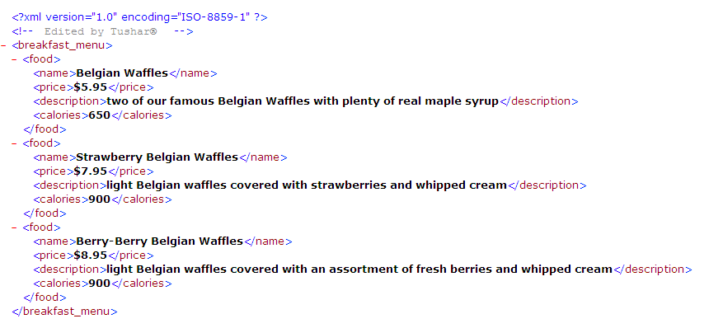
Figure 1: Output of foodmenu.xml

1.2: <<TODO>> Create XML files for storing Email data
Data need to be stored are:
- To
- From
- CC
- BCC
- Subject
- Body
Solution:
Step 1: Write your code using Visual Web Developer 2008\Eclipse.
Step 2: Save this file as email.xml.
Step 3: View the output in Internet Explorer

1.3: <<TODO>> Create an XML file for storing employee details as given in table
The following table describes the employee details.
The employee details should be stored inside the root element “EmployeeDetails”.

Employee code | Employee Name |  | DOJ | Total Experience | Department |  | Designation |  |  |  |  | Sal | Grade
Employee code | First Name | Last name | DOJ | Total Experience | Unit | loc | 1 | 2 | 3 | 4 | 5 | Sal | a | b | c | d
1111 | Seema | Dalvi | 09/08/97 | 12 | 3d | Mumbai |  |  |  | * |  | 21000 |  | *
222 | Bharati | Mantri | 12/01/99 | 5 | 4a | Pune |  | * |  |  |  | 12000 | *

1.4: Create an XML file to store employee details.
Payroll department has decided to use XML files as a rich data source, so the existing EMP table has to be converted into XML data source i.e. XML file need to be created for the below EMP table representing entire data (To Do)

EMPNO | ENAME | JOB | MGR | HIREDATE | SAL | COMM | DEPTNO
7369 | SMITH | CLERK | 7902 | 17-DEC-80 | 1100 | 200 | 20
7499 | ALLEN | SALESMAN | 7698 | 20-FEB-81 | 1600 | 24820 | 30
7521 | WARD | SALESMAN | 7698 | 22-FEB-81 | 1375 | 19700 | 30
7566 | JONES | MANAGER | 7839 | 02-APR-81 | 3175 |  | 20
7654 | MARTIN | SALESMAN | 7698 | 28-SEP-81 | 1375 | 20600 | 30
7698 | BLAKE | MANAGER | 7839 | 01-MAY-81 | 2850 |  | 30
7782 | CLARK | MANAGER | 7839 | 09-JUN-81 | 2450 |  | 10
7788 | SCOTT | ANALYST | 7566 | 19-APR-87 | 2000 |  | 20
7839 | KING | PRESIDENT |  | 17-NOV-81 | 5000 |  | 10
7844 | TURNER | SALESMAN | 7698 | 08-SEP-81 | 1650 | 23000 | 30
876 | ADAMS | CLERK | 7788 | 23-MAY-87 | 1430 | 200 | 20
7900 | JAMES | CLERK | 7698 | 03-DEC-81 | 1045 | 200 | 30
7902 | FORD | ANALYST | 7566 | 03-DEC-81 | 3200 |  | 20
7934 | MILLER | CLERK | 7782 | 23-JAN-82 | 1430 | 200 | 10
- Writing XML Schemas (XSD)
Goals | - Write XML Schema Definition (XSD).
Time | 180 minutes

2.1: Create a XML Schema definition document
Create a XML Schema definition document. We will then write a XML Document based on this XSD. Validate your XML against the XSD. (Refer Appendix B)
Solution:
Step 1: Write the following code and save it as “Shiporder.xsd”.
The Schema document looks like a typical XML document. The output can be seen in Internet Explorer.

<?xml version="1.0" encoding="ISO-8859-1" ?>
<xs:schema xmlns:xs="http://www.w3.org/2001/XMLSchema">
<!-- definition of simple elements -->
<xs:element name="orderperson" type="xs:string"/>
<xs:element name="name" type="xs:string"/>
<xs:element name="address" type="xs:string"/>
<xs:element name="city" type="xs:string"/>
<xs:element name="country" type="xs:string"/>
<xs:element name="title" type="xs:string"/>
<xs:element name="note" type="xs:string"/>
<xs:element name="quantity" type="xs:positiveInteger"/>
<xs:element name="price" type="xs:decimal"/>
<!-- definition of attributes -->
<xs:attribute name="orderid" type="xs:string"/>
<!-- definition of complex elements -->
<xs:element name="shipto">
<xs:complexType>
<xs:sequence>
<xs:element ref="name"/>
<xs:element ref="address"/>
<xs:element ref="city"/>
<xs:element ref="country"/>
</xs:sequence>
</xs:complexType>
</xs:element>
<xs:element name="item">
<xs:complexType>
<xs:sequence>

<xs:element ref="title"/>
<xs:element ref="note" minOccurs="0"/>
<xs:element ref="quantity"/>
<xs:element ref="price"/>
</xs:sequence>
</xs:complexType>
</xs:element>
<xs:element name="shiporder">
<xs:complexType>
<xs:sequence>
<xs:element ref="orderperson"/>
<xs:element ref="shipto"/>
<xs:element ref="item" maxOccurs="unbounded"/>
</xs:sequence>
<xs:attribute ref="orderid" use="required"/>
</xs:complexType>
</xs:element>
</xs:schema>
Example 2: shiporder.xsd

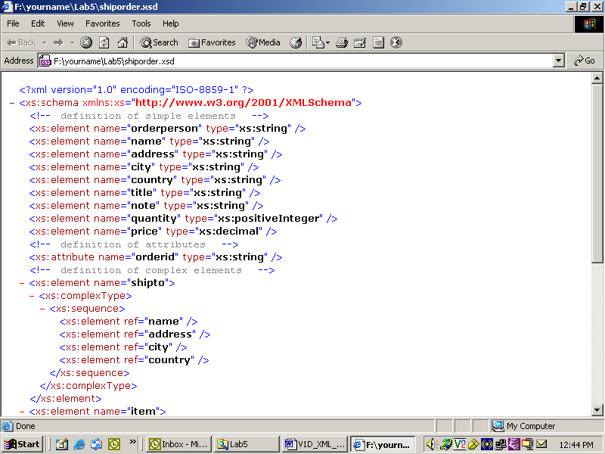
Figure 2: Output of Shiporder.xsd
Step 2: Now write an XML Document using the above XML Schema Definition.
Save this file as “Shiporder.xml”. View the output in Internet Explorer.

<?xml version="1.0" encoding="ISO-8859-1"?>
<shiporder orderid="889923"
xmlns:xsi="http://www.w3.org/2001/XMLSchema-instance"
xsi:noNamespaceSchemaLocation="shiporder.xsd">
<orderperson>John Smith</orderperson>
<shipto>
<name>Ola Nordmann</name>
<address>Langgt 23</address>
<city>4000 Stavanger</city>
<country>Norway</country>
</shipto>
<item>
<title>Empire Burlesque</title>
<note>Special Edition</note>
<quantity>1</quantity>
<price>10.90</price>
</item>
<item>
<title>Hide your heart</title>
<quantity>1</quantity>
<price>9.90</price>
</item>
</shiporder>
Example 3: Shiporder.xml

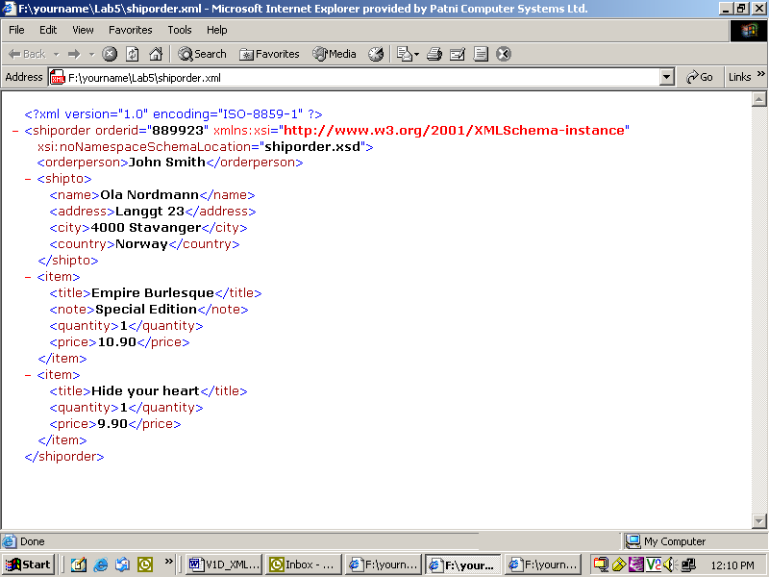
Figure 3: Output of Shiporder.xml

2.2: Create XSD for the XML file created in Lab exercise 1.2 and 1.4.

2.3: Create XSD for the given book details in “Library.xml” file.
Consider the following data exists in “Library.xml” file and create XSD for the same.
<Library >
<Book>
<Title>Dead to the World </Title>
<Author>Charlaine Harris </Author>
<Publisher>ABC Publishing company</Publisher>
<Cover cover_type="Hardbook"></Cover>
<Category cat_type="Horror"></Category>
<ISBN isbn_num="Z1"></ISBN>
<Rating rate_Val="5"></Rating>
<Price>$13.97 </Price>
<Comments>A good book</Comments>
</Book>
<Book>

<Title>Gardens of the Moon </Title>
<Author>Steven Erikson</Author>
<Publisher>XYZ Publishers</Publisher>
<Cover cover_type="Hardbook"></Cover>
<Category cat_type="SCI-FI"></Category>
<ISBN isbn_num="Z3"></ISBN>
<Rating rate_Val="4"></Rating>
<Price>$17.65</Price>
<Comments>A wonderful book</Comments>
</Book>
</Library>
Example 4: Library.xml

Appendices

Appendix A:
XML Editors:
- Notepad++: Notepad++ with XML Tools plugin can be used for validating the XML against the xsd. XML Tools plugin can be downloaded Plugins -> Plugin Manager -> Show Plugin Manager in Notepad++.
Xsd file can be created in Notepad++ as follows:

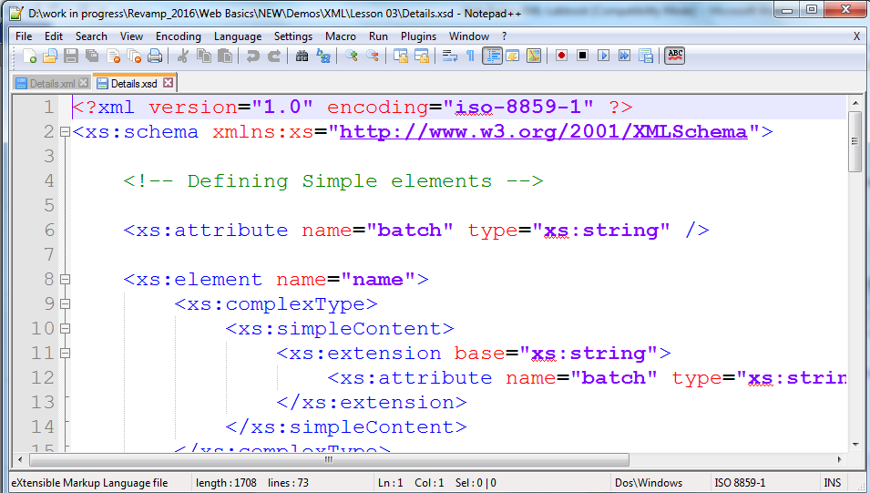

Xml file can be created in Notepad++ as follows:
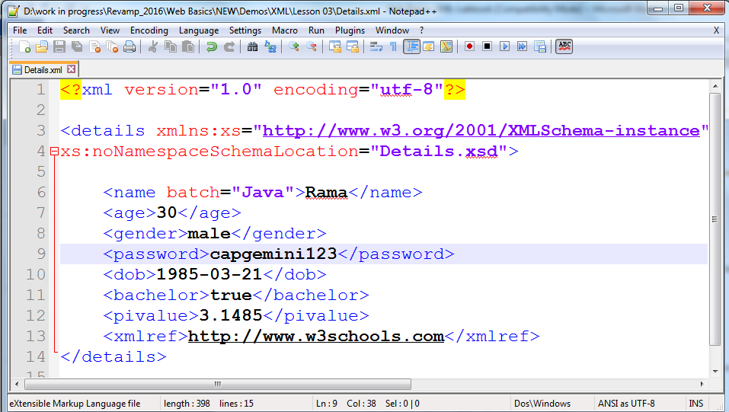

Validation of xml can be done as follows:
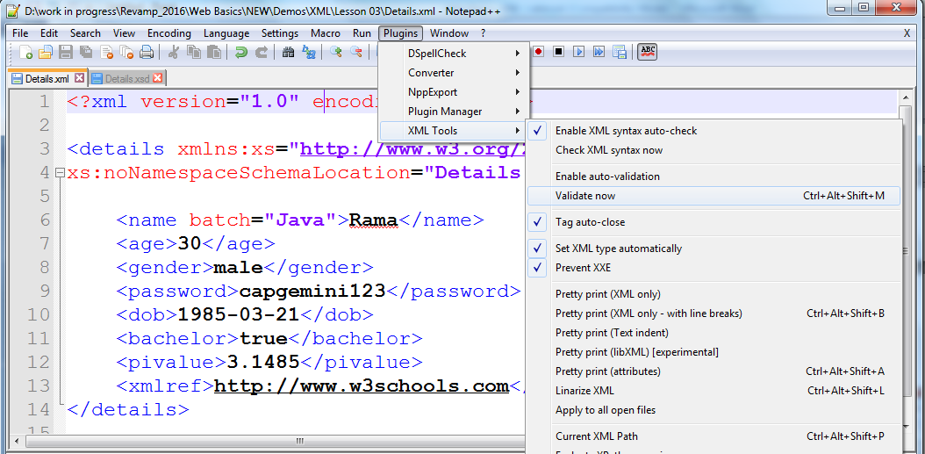
- Eclipse Luna: XML editor comes with a full range of features you would expect from an eclipse editor. It includes IntelliSense, color-coding, brace matching, and formatting.
You can download eclipse from the following url:
http://www.eclipse.org/downloads/
- When you click on eclipse.exe file, the screen for Creating new XML file in eclipse is displayed as follows:

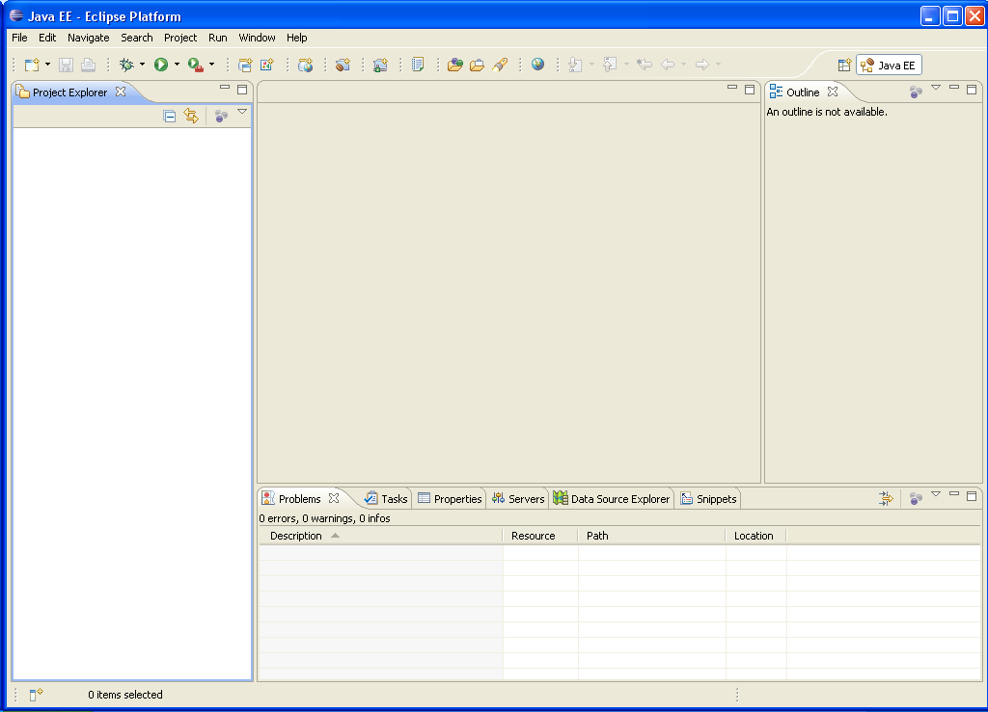
Figure 4: Opening eclipse Luna
- For writing XML file, we need to create General Project as follows:
  - Select New → Project.

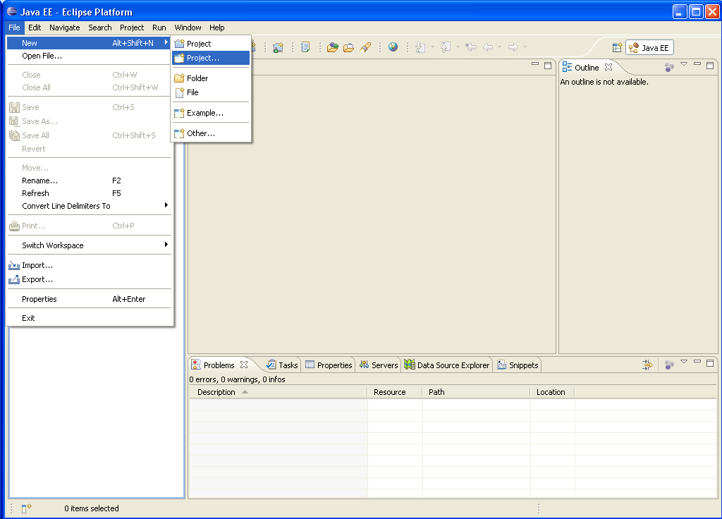

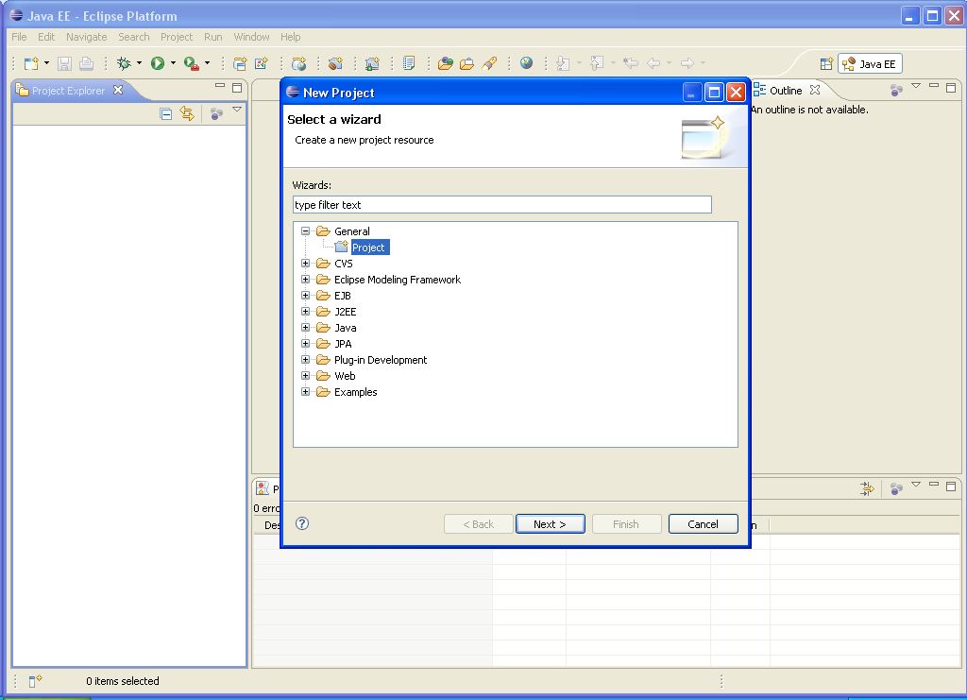
Figure 5: Creating General Project
  - Then click Next button. Type the project name and click Finish.
- Then for creating new XML file, follow the steps shown in the screenshots:

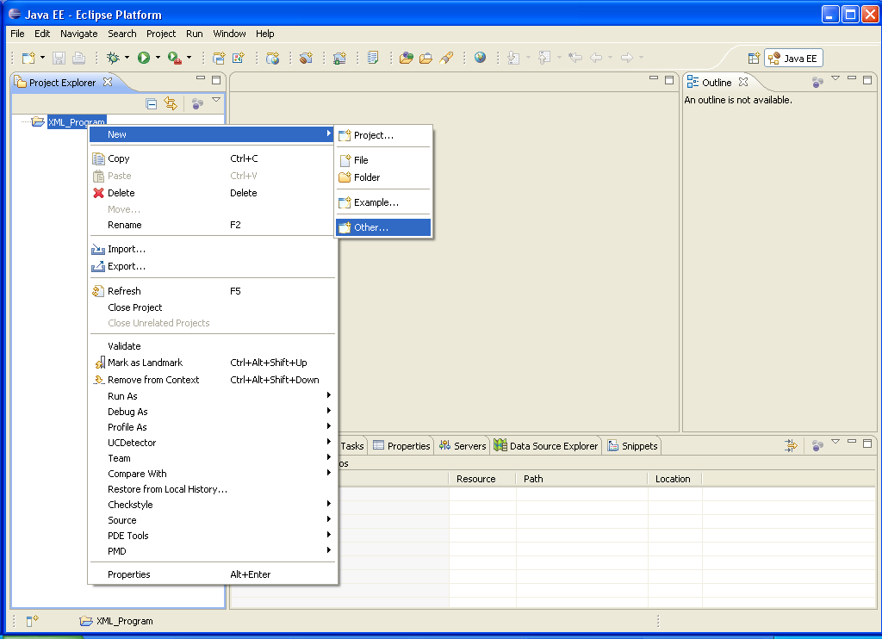

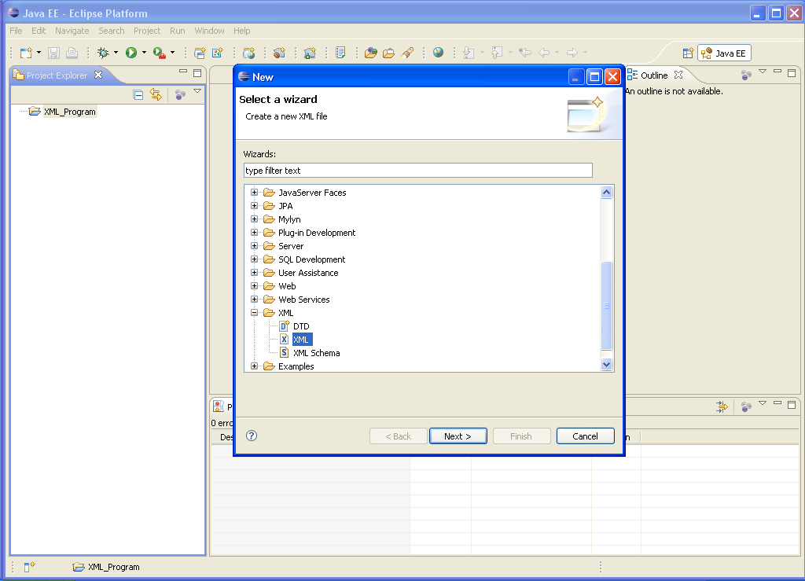
- Select XML file.
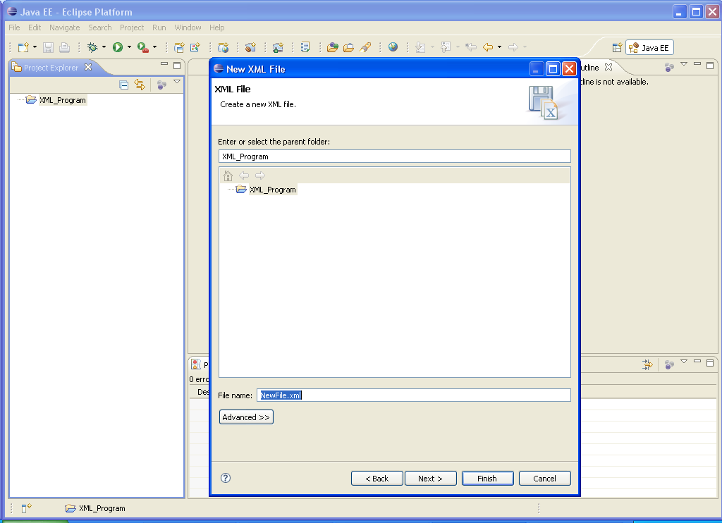

- Give the file name, and click Next button.

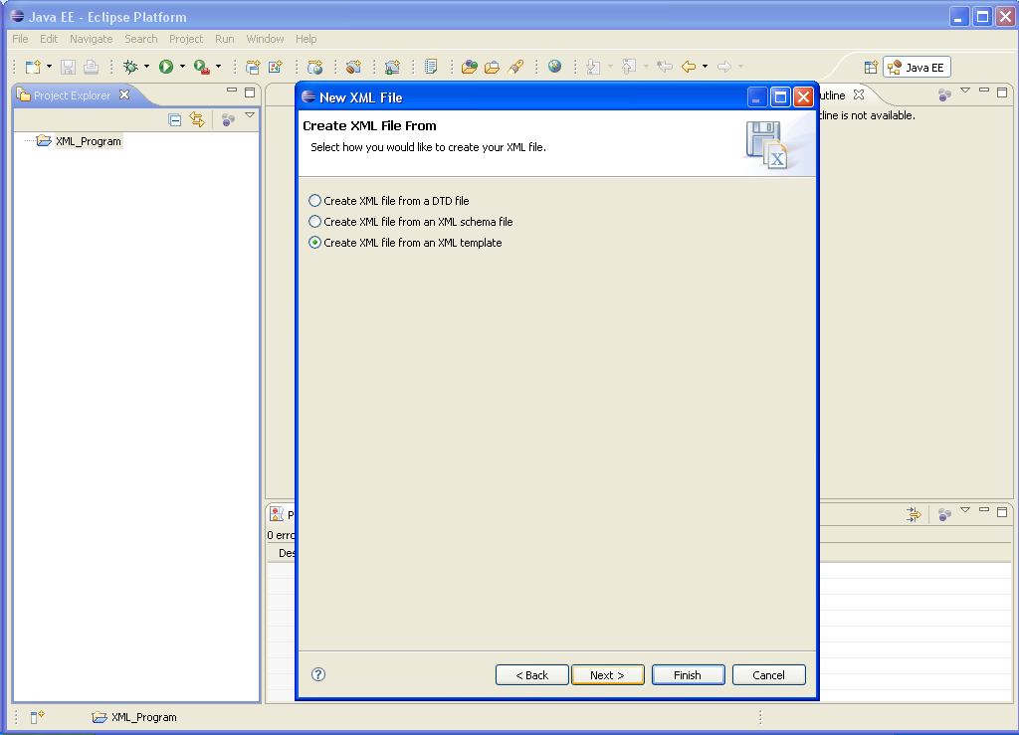
Fig 4 : Creating XML file
- Select any one of the option as per the requirement. Then click Finish button.

- For creating Schemas, follow the steps given below:
  - Go to File → New → Other → XML → XML Schema → Next
  - Write the file name, and click Finish.
- For viewing the output, follow the steps given below:
  - Right click File, and select Open With → Other → select Internet Web Browser →OK.

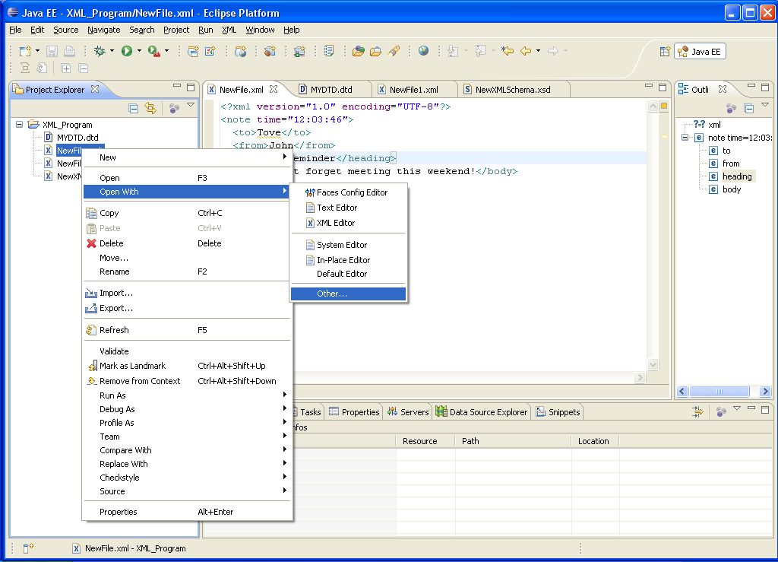

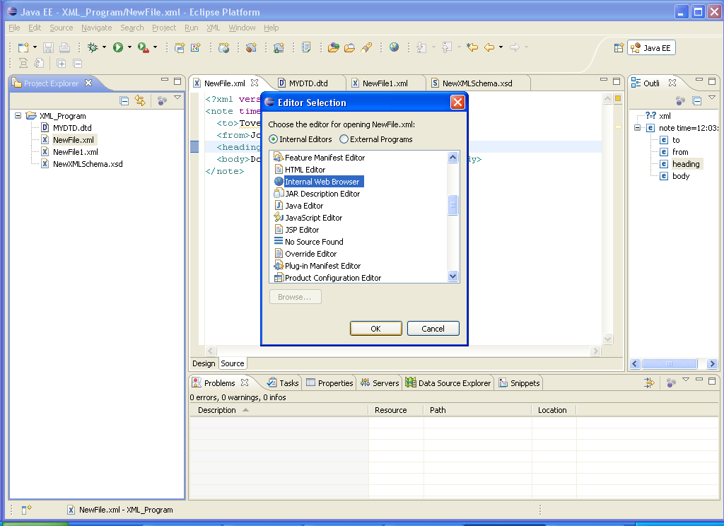
Figure 6: For viewing output
- Visual Studio 2008
- Go to Visual Studio Team System 2008
- Go to File->New->File take new XML file
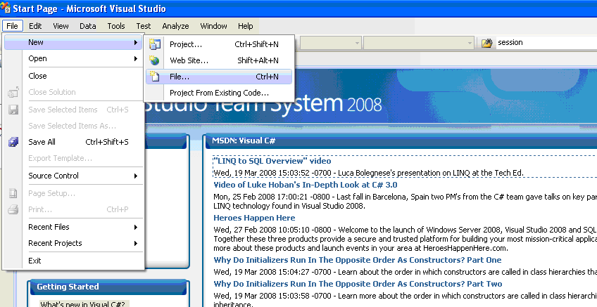

- Select XML File
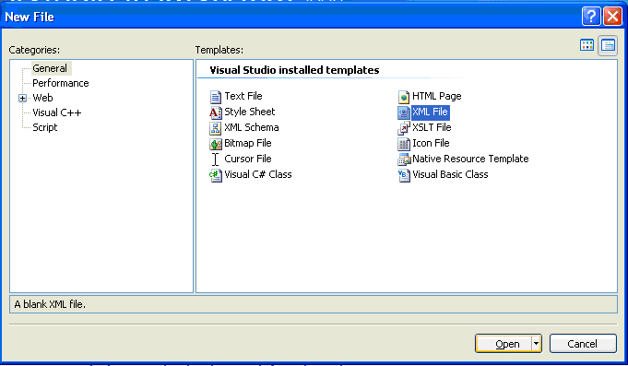
- Creating Schema file using Visual Studio Team System 2008
- Go to Visual Studio Team System 2008
- Go to File->New->File take new XML Schema

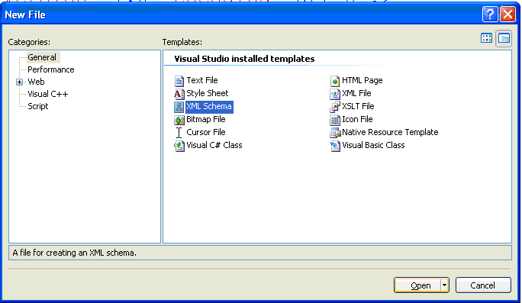
- Attaching Schema file to XML file for validation
Follow the steps given in Appendix A.2 to create XML file then follow the following steps to attach schema file.
- Go to properties window (press F4) and Select Schema tab.

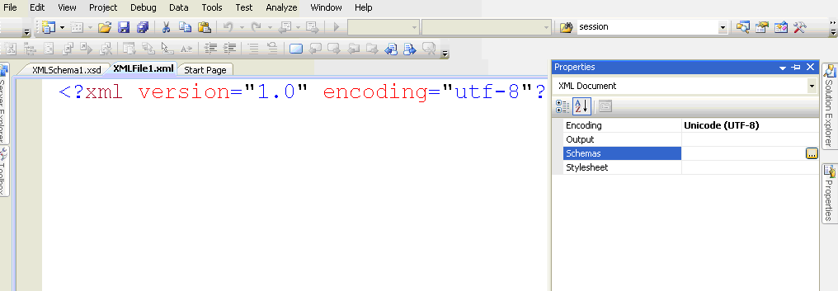

- Click on Add & browse your Schema file -> Click on OK

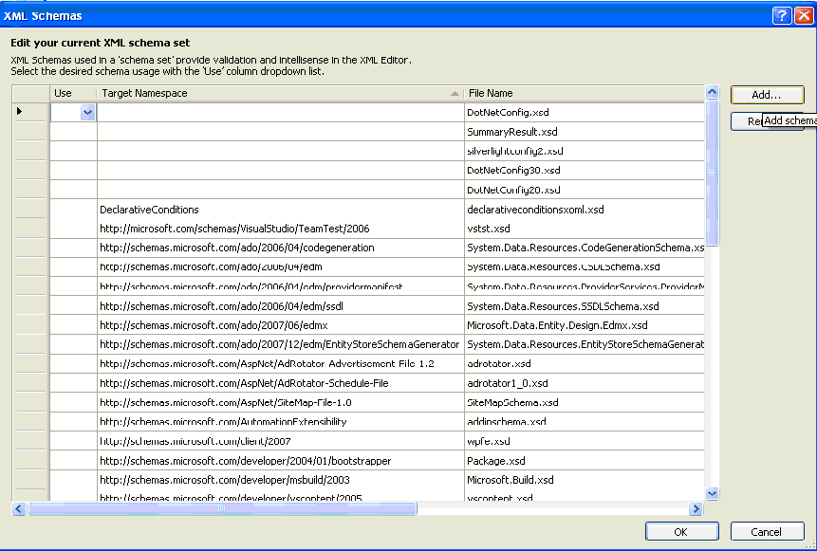

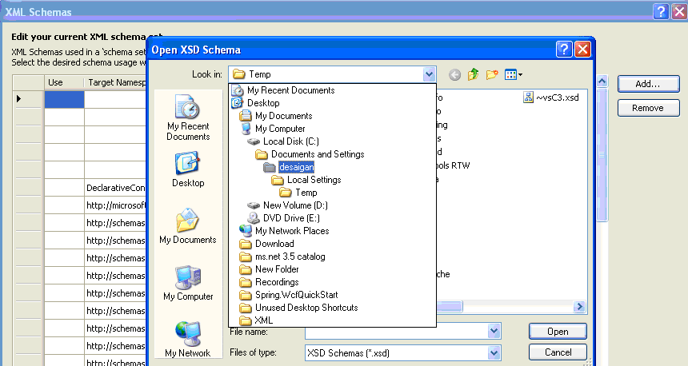
Validating your XML file against Schema file will be taken care by Editor itself & necessary errors will be shown.

Appendix B:
- Steps for creating XML file from the existing DTD and Schema.
- Go to File → New → Other → XML → DTD.
- Write the file name, and click Next button.
- Select “Create XML file from a DTD file” option.

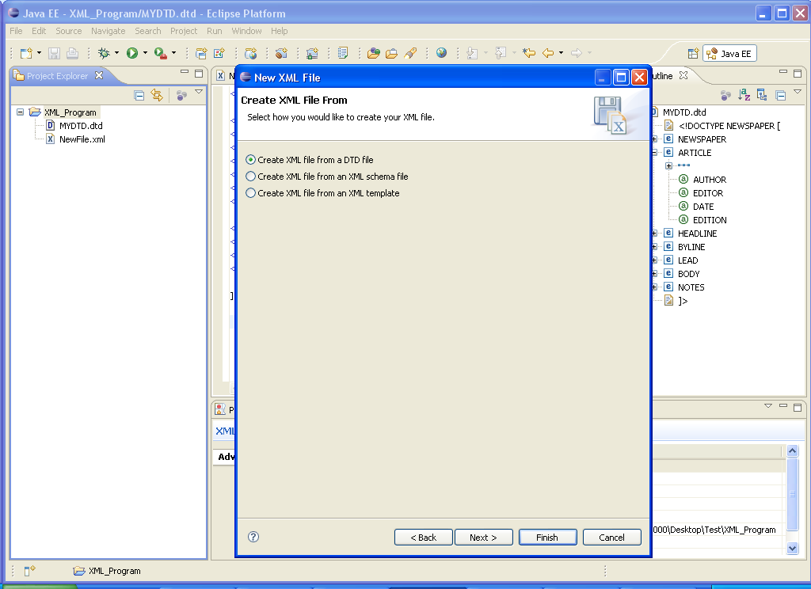
Figure 7: For creating XML file from a DTD file
Click Next button, select DTD file name, and click Next.
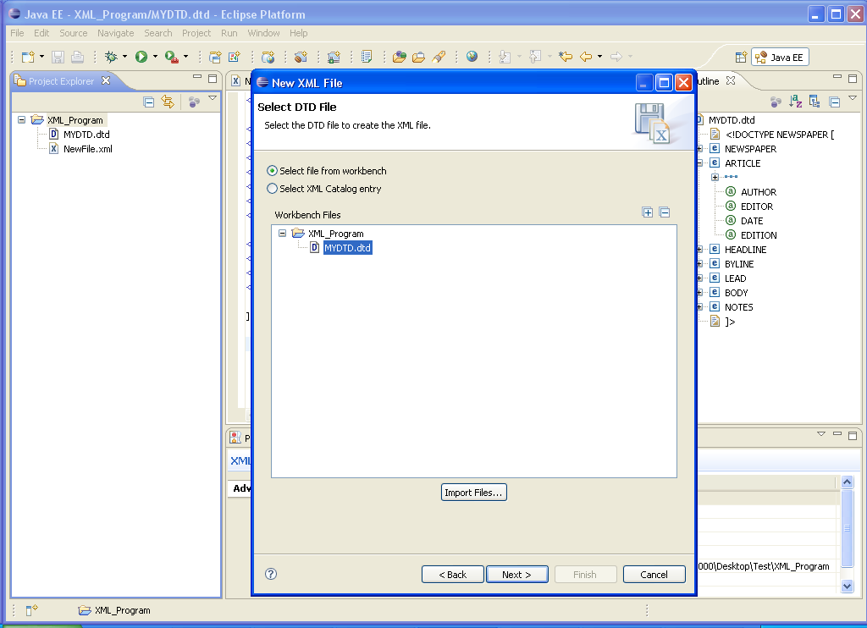
Figure 8: Selection of a DTD file
Now click Next, select the root element, and click Finish.
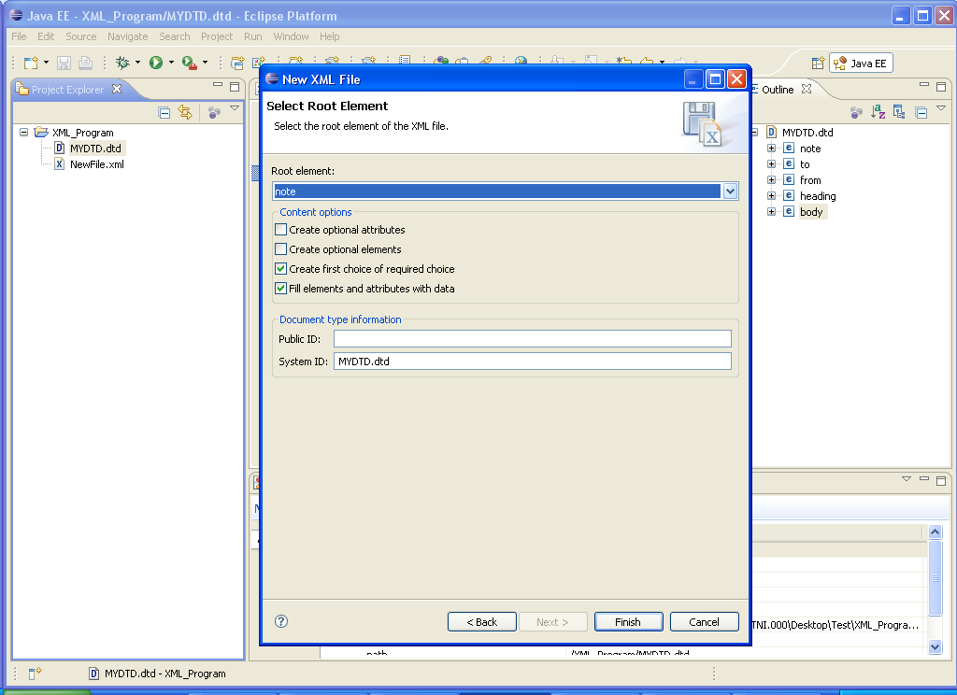
Figure 9: Select Root element for a XML file
- For creating XML file from existing schema file, you should follow the same steps, except select “Create XML file from an XML Schema” option.
Validating a XML document against a DTD or Schemas:
When we create a XML document, we need to check for it “Validity” and its “Well Formedness”. Eclipse allows us to validate the of the XML document against a DTD or Schema.
Right click the XML file, and select Validate option. If there is any problem, then you can view it in Problem tab.
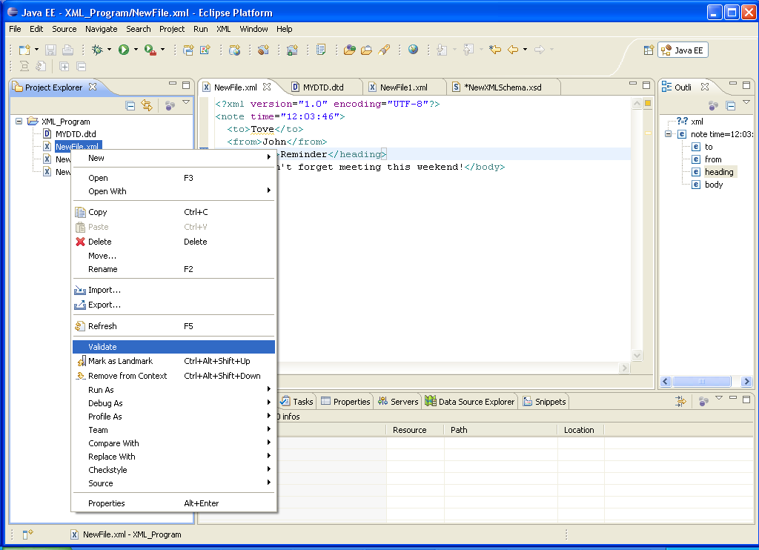
Figure 10: For Validating a XML file

Appendix C: Table of Figures
Figure 1: Output of foodmenu.xml 8
Figure 2: Output of Shiporder.xsd 15
Figure 3: Output of Shiporder.xml 17
Figure 4: Opening eclipse Luna 21
Figure 5: Creating General Project 23
Figure 6: For viewing output 29
Figure 7: For creating XML file from a DTD file 36
Figure 8: Selection of a DTD file 37
Figure 9: Select Root element for a XML file 38
Figure 10: For Validating a XML file 39

Appendix D: Table of Examples
Example 1: foodmenu.xml file 8
Example 2: shiporder.xsd 14
Example 3: Shiporder.xml 16
Example 4: Library.xml 18

